NEIGHBOR TO FOOD &




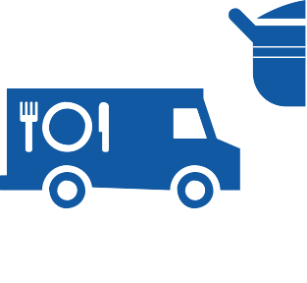
Including information on SNA Meals for Kids, Senior Meals, Pantries, Farmers’ Markets,

The Bronx

HOOD GUIDE ASSISTANCE


P/Food Stamps, Soup Kitchens, Food and more...
2017
ABoUT

ThIS GUIDe WAS ProDUCeD BY hUnGer Free nYC To ConneCT ThoSe In neeD WITh Free CoMMUnITY reSoUrCeS.
We hoPe IT ProVeS USeFUL To YoU.

This Guide was made possible by funding from the New York City Council through a grant administered by the New York City Human Resources Administration and the Walmart Foundation.
This Guide is also avail- able as a free PDF on our web site, www.hungerfreenyc. org/guides.
To order additional copies of this guide, call
(212) 825-0028 or send us an email at guides@ hungerfreenyc.org.

50 Broad Street, Suite 1103 New York, NY 10004


(212) 825-0028
www.hungerfreenyc.org

ConTenTS

Food Stamps/SNAP 4


Food for Kids 8
Senior Meals 13
Soup Kitchens & Food Pantries 14
Employment & Training 27
From the Farm 28
Map of Locations 32
Other Assistance 38
Emergency Numbers 39

Neighborhood Guide to Food and Assistance - The Bronx edition
SNAP/
FOOD STAMPS
SNAP benefits, the new name for food stamps, can help put healthy food on the table by providing monthly assistance to purchase food at authorized grocery stores and farmers’ markets. Benefits are provided monthly through a plastic benefit card, similar to a debit or credit card.

WHAT SHOULD I KNOW?
TERMS

EBT
Stands for Electronic Benefit Transfer. It's the system the goverment uses to disburse benefits.

SNAP
Stands for Supplemental Nutrition Assistance Program. “SNAP benefits” is the same thing as “food stamps.”
Employment does not interfere with getting SNAP. Even if you are working, but earning low wages, you may be eligible.
Average SNAP benefits are over $100 per person per month, and $250 or more for families. That means that SNAP benefits for the average family receiving them totals more than $3,000 worth of food support each year.
Farmers’ markets often accept SNAP benefits, so you can purchase fresh produce and food-producing seeds and plants using your benefits. For a complete list of farmers’ markets that accept them, see page 28.

AM I ELIGIBLE?

AMPS T S

OOD F

Eligibility is based on household size, income, expenses and other factors. Households have to meet income tests to receive benefits, but households that have members who are disabled or elderly (60 or older), or have out-of-pocket expenses for child care or dependant care, can have higher incomes and still be eligible.
SNAP/FOOD STAMPS

NUMBER OF PEOPLE IN HOUSEHOLD
1
2
3
4
Each additional household member
MONTHLY INCOME LIMIT (PRE-TAXES) 1
$1,287
$1,736
$2,184
$2,633
+$451
(approximately)
MAX. MONTHLY SNAP BENEFITS 2
$194
$357
$511
$649
+$146
(approximately)

1In effect
10/1/16 - 9/30/17.

2In effect
10/1/16 - 9/30/17.

If you meet the above income qualifications, it doesn't matter how much money you may or may not have in countable resources. In other words, you can save money for education, a home purchase, or retirement and still receive SNAP benefits.

IMMIGRANT ELIGIBILITY

Legal immigrants can often receive SNAP benefits if they:
- have lived in the country for 5 years or more; or
- are children (under age 18).
Ineligible immigrant parents can still receive benefits for their children even if a parent does not qualify.
Certain non-citizens, such as those admitted for humanitarian reasons, may also be able to receive benefits.
Immigration status is not negatively affected if you apply for or receive SNAP benefits.

HOW TO APPLY

Apply at Select Community Organizations
1

Call either of the below numbers to see if you may be eligible for benefits. If so, you’ll be offered an appointment at an agency in your community, where you’ll receive help in submitting your application electronically.
Hunger Free NYC
646 355 1475 & 646 350 1104

ACCESSNYC
2
SNAP/FOOD STAMPS

Apply online at: www.nyc.gov/accessnyc

Visit Your Local HRA Office
3

Apply at a SNAP office near you:
- Concourse SnAP Center
1375 Jerome Ave., 2nd Floor, 10452
718 722 8013
Mon-Fri 8:30am-6pm; Sat 9am-5pm
- hunts Point SnAP Center
845 Barretto St., Level B, 10474
718 722 8013
Mon-Fri 8:30am–5pm
- Crotona SnAP Center
1910 Monterey Ave., 5th Floor, 10457
718 722 8013
Mon–Fri 8:30am–5pm

You can also call 718 557 1399 to find a SNAP office near you and for information about qualifications, guidelines, and applications.

FOOD FOR KIDS

WOMEN, INFANTS & CHILDREN

WIC is the Women, Infants & Children Program.

QUICK FACTS
WIC is for low-income pregnant women, breast-feeding women, and women with children up to the age of five.
You can work and still get WIC.
You can continue to get cash assistance or SNAP benefits/food stamps while receiving WIC.
You can get WIC even if you are undocumented or not a citizen.

HOW TO APPLY
To find the WIC office nearest you call 800 522 5006, call 866 3-HUNGRY or visit these local WIC offices.

- Morris heights health Center - St. Ann's
625 E. 137th St., 10454
718 425 3888
Mon-Wed 8:30am-5pm; Thu 10:30am-7pm; Fri 10am-5pm; Sat once/month 9:30am-2pm
- Lincoln hospital - Segundo ruiz Belvis Center
545 E. 142 St., 10454
718 579 1707
Mon 7:30am-7pm, Tue-Fri 7:30am-5pm
- Lincoln Medical & Mental health Center
234 E. 149 St., 10451
718 579 5397
Mon 8:30am-7pm, Tue-Fri 8:30am-5:45pm, Sat 8:30am-4:30pm
- Montefiore Medical Center- 161 St WIC
432 E. 161 St., 10451
FOOD FOR KIDS
718 585 4695
Mon, Wed-Fri 8am-4pm; Tue 9am-5pm all by appt. only
- Urban health Plan - Bronx WIC
1070 Southern Blvd., 10459
718 589 4776
Mon 9am-5 pm, Tue 8:30am-5pm, Wed 8:30am-6pm, Thu
7:30am-5pm, Fri 9am-3pm, Sat 8:30am-1pm
- Lincoln hospital - Morrisania Longwood WIC Program 1125 Grand Concourse (entrance on McClellan Ave.), 10452 718 588 1887/1501
Mon, Tue, Thu 9am-5pm; Wed, Fri 8:30am-4:30pm, every other Sat 8:30am-4:30pm all by appt. only
- Lincoln hospital - Morrisania neighborhood Family health Center WIC Program
1225 Gerard Ave., 10452
718 960 2805
Mon-Thu 8am-8pm; Fri 8am-5pm, every other Sat 8:30am-4pm, all by appt. only
- Bronx Lebanon hospital Center 21 East Mount Eden Ave, 10452 718 583 4278
Mon, Tue, Thu 8am-3pm, Wed 8am-6pm (If working/in school),
Fri 8am-12pm, 2nd Sat 9am-2pm by appointment.
- Public health Solutions east Tremont WIC Center
519 East Tremont Avenue, 10457
718 294 6887
Mon 11am-6:30pm, Tue-Fri 8:30am-4pm
- St. Barnabas hospital Ambulatory Care Building
4487 3rd Ave., 10457
718 960 6257
Mon-Thu 8:30am-4:30pm, Fri 8:30am-5pm
- St. Barnabas hospital
2021 Grand Concourse, 1st Floor, 10453
718 901 9510
Mon-Thu 8:30am-6pm, Fri 8:30am-5pm, Sat 9am-12pm
- Morris heights health Center 85 W. Burnside Ave, 10453 718 716 4400
Mon 8:30am-8pm, Tue 8am-5pm, Wed 8:30am-7:30pm, Thu
8:30am-7pm, Fri 9:30am-5pm, Sat 9:30am-2pm
- Morris heights health Center - Walton
25 E. 183rd St., 10453
718 839 8903
Mon, Wed 8:30am-7:30pm; Tue 8am-5pm; Thu 8:30am-5pm; Fri
9:30am-5pm; 1st, 2nd, 4th Sat 9:30am-2pm
- Jacobi Medical Center WIC
1400 Pelham Parkway South, Builg #1, 4 North West, Suite A, 10461
718 918 4000
Mon-Thu 8:30am-4pm, Fri 8:30am-3pm
- Montefiore Medical Center - Westchester Square WIC
22 Westchester Square, 10461
718 829 4401
Mon, Tue, Thu, Fri 8am-4pm; Wed 9am-5pm all by appt. only
- Morris heights health Center - Parkchester
2019 Westchester Avenue, 10462
718 931 2030
Mon-Wed 8:30am-5pm; Thu 10:30am-7pm; Fri 10am-5pm; Sat once/month 9:30am-2pm
- St. Barnabas hospital - 188th St.
260 E. 188 St., 10458
718 220 2020
Mon-Thu 8:30am-6pm, Fri 8:30am-5pm, Sat 9am-12pm
- Montefiore Medical Center - Fordham Plaza WIC
1 Fordham Plaza, 10458
718 405 4066
Mon-Wed, Fri 8am-4pm, Thu 9am-5pm all by appt. only
- north Central Bronx hospital WIC
3424 Kossuth Ave., 10467
FOOD FOR KIDS
718 519 3488
Mon-Thu 8:30am-4pm, Fri 8:30am-3pm
- Montefiore new rochelle - White Plains WIC
3401 White Plains Road, 10467
718 547 6345
Mon 9am-6pm; Tue, Thu 9am-6:30pm; Wed 9am-4:30pm; Fri, Sat 9am-12:30pm
- Morris heights health Center - Vanguard
825 E. 233rd St., 10466
347 418 3399
Mon-Wed 8:30am-5pm; Thu 10:30am-7pm; Fri 10am-5pm; Sat once/month 9:30am-2pm
- Montefiore new rochelle - 233 St WIC
1600 E. 233rd St., 10466
718 231 5800
Mon 9am-6pm; Tue, Thu 9am-6:30pm; Wed 9am-4:30pm; Fri, Sat 9am-12:30pm
SChooL & SUMMer Me ALS

SFSP is the Summer Food Service Program, also known as Summer Meals.
QUICK FACTS
During school, free breakfasts are available to all children regardless of income, with no paperwork required.
Many public school students are also eligible for free or reduced price lunch. An application may be required.
Eligibility for school meals is not impacted by immigration status.
In June, July and August, lunch and breakfast are served for free to all children under 19 at many public schools, houses of worship, recreation centers, and community centers - no application or registration required.
Visit www.schoolfoodnyc.org for more information about school breakfast, school lunch, and summer meals. For nearby summer meals sites, text FOOD to 877-877, call 311, or call the National Hunger Hotline at 866 3-HUNGRY.

Senior centers often serve meals for older people. Some centers offer free meals, oth- ers ask for a small contribution (from fifty cents up to a few dollars). This contribution may be voluntary or required. Senior cen- ters and other sites with food for seniors are marked with in the Soup Kitchens and Food Pantries section.
SENIOR MEALS
MEALS AT SENIOR CENTERS
SENIOR MEALS
FIND YOUR LOCAL SENIOR CENTER
Call 311 and be prepared to provide your ZIP code to the operator.

MEALS-ON-WHEELS PROGRAM

If you are homebound and over the age of 60, you can receive home-delivered meals up to 7 days a week. Household income does not affect eligibility.
HOW TO APPLY
To request meals-on-wheels service, call your local case management agency.
To find the appropriate agency, contact the Citymeals-on-Wheels’ Program Department at 212 687 1234 or the National Hunger Hotline at 866 3-HUNGRY.

SOUP KITCHENS FOOD PANTRIES


Agencies listed as soup kitchens provide prepared meals during
their listed serving times, while agencies listed as food pantries provide bags of food to be prepared at home.
While we try to keep this list as accurate and up-to-date as possible, we recommend calling the agency before going to confirm their schedule. Some agencies require a referral, ID, or proof of address. To confirm, contact the agency directly, call the NYC Emergency Food Line at 866 888 8777 or call the National Hunger Hotline at 866 3HUNGRY. Agencies marked with are senior centers and/or provide food specifically for seniors.
SoUTh Bronx (Lower)
10454, 10455, 10451
- St. Luke's Food Pantry 623 E. 138th St., 10454 718 665 6677
Food Pantry: Fri 10am-12pm ID required.
- St. Ann's Church of Morrisania
295 St. Ann's Ave, 10454
718 585 5632
Soup Kitchen: Sun 11am-2pm
Food Pantry: Wed, Fri 10:30am-2pm Medicaid card or ID required for pantry.
- St. Jerome Community Food Pantry
PANTRIES & KITCHENS
330 E. 138th St., 10454
718 402 7866
Food Pantry: Wed 4pm -6pm
ID required, serves residents of 10454.
- Abraham house
340 Willis Avenue, 10454
718 292 2867
Food Pantry: Sat 6:30am-7:30am ID required.
- every Day is a Miracle 411 East 143rd St., 10454 347 618 1162
Food Pantry: Fri 10am-1:30pm ID required.
- Way out Church Ministries 518 East 148th Street, 10455 718 665 8069
Food Pantry: Tue 8am-10am, fresh produce every day 10am- 2pm
- United Bronx Parents Food Pantry
603 Prospect Ave, 10455
347 996 1879
Food Pantry: Wed, Fri 10am-12pm
Wed for last names A-M, Fri for last names N-Z. ID required. Bring cart/bags.
- United Bronx Parents Soup Kitchen
1006 East 151st St., 10455
718 991 7100
Soup Kitchen: Mon-Fri 2:30pm -4pm First come, first served.
- The relief Bus - Bronx Brook Ave.
Brook Ave. between 147th and 148th, 10455 800 736 2773
Mobile Soup Kitchen: Sat 10am -2pm.
- City harvest St. Mary's Mobile Market
575 Trinity Avenue, parking lot on Cauldwell Avenue, 10455 Mobile Market Pantry: 2nd Sat, 4th Tue 9:30am-11:30am Residents of the St. Mary's, E.R. Moore, Bronxchester and Adams Houses, members of Urban Health Plan, and the entire 10455 zip code. All food is fresh fruits and vegetables. Families must register to participate - bring proof of address and a photo ID. For further information on registration please call 646 412 0743. For information on available produce and dates of distribution, please call the Mobile Market Hotline at 866 444 0244.
- St. Margaret's episcopal Church
940 E. 156th St., 10455
718 589 4430
Soup Kitchen: Sun 9am-10am, Wed 6pm-7pm
- Give them To eat - Iglesia evangelica espanola
800 E. 156th St., 10455
718 993 1260
Soup Kitchen: Tue 1pm-3pm Food Pantry: Fri 12pm-3pm ID prefered.
- Transfiguration Lutheran Church
763 Prospect Ave, 10455
718 378 3588
Food Pantry: Mon 1pm-3pm
- BooM!health harm reduction Center 226 East 144th St., 3rd Floor., 10451 718 292 7718 x228
Soup Kitchen: Thu 12:30pm-1:15pm
- Grand Central Food Program - Lincoln hospital
Morris Ave. & 148th St., 10451 212 776 2000
Mobile Soup Kitchen: every day 8pm Come on time - distribution is mobile.
- The relief Bus - Bronx Courtland Ave. Courtlandt Ave. between 151st and 152nd, 10451 800 736 2773
Mobile Soup Kitchen: Wed 10am-2pm
- City harvest Melrose Mobile Market
PANTRIES & KITCHENS
286 East 156th St. at the Classic Center, 10451
Mobile Market Pantry: 2nd Sat, 4th Wed 9:30am-11:30am Residents of Melrose, Morrisania Air Rights, Andrew Jackson Houses and Members of Boricua Community Health Center or Bronx Defenders only. All food is fresh fruits and vegetables. Families must register to participate - bring proof of address and a photo ID. For further information on registration please call 646 412 0743. For information on available produce and dates
of distribution, please call the Mobile Market Hotline at 866 444 0244.
- Salvation Army Bronx Citadel
425 E. 159th St., 10451
718 665 8472
Soup Kitchen: Mon, Wed, Fri 1pm-2pm
Food Pantry: Tue 10am-1pm
ID and proof of address required to register for pantry, by appointment only. Serves residents of 10451, 10452, 10454-
10456, 10459, 10465, 10472-10474.
- Missionary Church of Christ 937 Teller Avenue, 10451 718 588 4545
Food Pantry: 2nd, 4th Sat 10am-12pm

SoUTh Bronx (Upper)
10452, 10453, 10457, 10456, 10459, 10474, 10460
- Grand Central Food Program - 164th St. & ogden
NE corner of 164th St. & Ogden Ave., 10452 212 776 2000
Mobile Soup Kitchen: every day 8:25pm Come on time - distribution is mobile.
- The Momentum Project at Church of God of Prophecy
85 East 165th St at Gerard & Walton Aves, 10452 212 691 8100
Soup Kitchen: Wed 11am-1pm, 4pm-6:30pm Dinner clients must complete intake at 3pm.
- Mid-Bronx Food Pantry
1125 Grand Concourse, 10452
718 410 6735
Food Pantry: 3rd Fri 9:30am-12pm
ID required for all household members.
- Bread Basket at Woodycrest United Methodist Church
89 West 166th St, 10452
718 538 7500
Soup Kitchen: Wed 12pm -2pm
- WheDCo - Women's housing and econ. Dev. Corp.
50 East 168th Street, 10452
718 839 1100
Food Pantry: Wed 9:30am
Tickets distributed starting at 7:30am to first 30 people. ID and proof of address required. Emergency bags provided as needed Mon-Fri 9am-5pm.
- Tolentine Zeiser Community Life Center
1261 Shakespeare Ave., 10452
917 549 8958
Food Pantry: Fri 9am-11am
Emergencies anytime. Can come once/month.
- Grand Central Food Program - 170th & Jerome
170th St. & Jerome, 10452 212 776 2000
Mobile Soup Kitchen: every day 8:30pm Come on time - distribution is mobile.
- True Gospel Tabernacle Church
1 West Tremont Ave., 10453
718 901 2786
Food Pantry: Tue 1pm, Wed 4pm, Thu 11am
Photo ID required. Food distributed by last name - A-F starts 1st Thu, G-L 2nd Thu , M-R 3rd Thu , S-Z 4th Thu, 5th Thu no pantry.
- heights Pantry/ Bronxworks, Inc. 200 West Tremont Ave., 3rd Fl, 10453 718 299 0300
Food Pantry: 1st, 3rd Fri 7am-11am
1st Fri is for 60 and under, 3rd Fri for 60+.
- St. edmunds Youth Programs, Inc.
PANTRIES & KITCHENS
1905 Morris Avenue, 10453
718 466 9370
Food Pantry: Thu 12pm-2pm
Tickets distributed Thu 8am. Occasional Mon distribution, call to check.
- Davidson Community Center 2038 Davidson Ave., 10453 718 731 6360
Food Pantry: Wed 9am-12pm
- Bronx Works Morris Innovative Senior Center
80 East 181st St., 10453
718 933 5300
Food Pantry: 2nd Fri 1:30pm-2:30pm (seniors only); last Fri
1:30pm-2:30pm (open to community) Tickets for pantry are distributed at 7:30am.
- Libres Por Jesucristo 609 E. 182nd St., 10457 646 408 3909
Food Pantry: Wed 1pm-3pm Tickets distributed Wed 9am.
- Abrigo Del Altisimo
2009 Monterey Ave., 10457
718 669 4826
Food Pantry: Tue 2pm-4pm
- Joshua and Caleb Ministry Inc. Food Pantry
1688 Webster Avenue, 10457
718 328 5900
Food Pantry: Sat 11am-12pm ID preferred.
- Bronx Seventh Day Adventist Church
1695 Washington Avenue, 10457
917 351 8777
Food Pantry: Thu 2pm-5pm.
ID required for registration. Provide emergency food, clothing pantry, and referrals.
- Vineyard Food Pantry 1140 Teller Avenue, 10456 718 865 4011
Food Pantry: Sat 10am-12pm Photo ID required.
- Inspirational Gospel Assembly
1211 Brook Avenue, 10456
347 272 0596
Food Pantry: Sat 11am-1pm Photo ID required.
- St. Augustine Food Pantry & Clothing Distribution
1183 Franklin Ave., 10456
718 893 0072 ext.15
Food Pantry: Mon 9:30am-1pm, Thu 5pm-7-pm for working people (bring pay stub)
ID required.
- new Covenant Community Development Corporation
1175 Boston Road, 10456
718 328 6072 x119
Food Pantry: Thu 10am-1pm ID required for registration.
- new Zion Pilgrim Baptist Church
1040 Washington Ave., 10456
718 292 4165
Food Pantry: Fri 9am-12pm Must register first.
- Gospel hill Baptist Church
3265 3rd Ave., 10456
718 585 6730
Food Pantry: Tue 10am until food runs out
ID required. Line forms at 7am. Pantry may be open other days, call to check.
- Morrisania revitalization Corp. Food Pantry
576 East 165th St., 10456
718 541 4597
Food Pantry: Fri 10am-12pm Photo ID preferred.
- Manna of Life/Fellowship Chapel
PANTRIES & KITCHENS
578 East 166 Street, 10456
347 577 5788
Soup Kitchen: Sat 11am-1pm
Food Pantry: Thu, Fri - call Mon-Wed for appointment
- PAThhSeo at Caldwell Temple AMe Zion Church
1288 Rev. James A. Polite , 10459 844 818 FOOD 3663
Soup Kitchen: Sat 8am-2:30pm
Food Pantry: Sat 8am-2:30pm
- The hopeLine
884 E. 163rd St., 10459
718 402 1212
Food Pantry: Wed 10:45am-2:30pm, Thu 9:30am-1:30pm By appointment only. Clothing bank available.
- Grand Central Food Program - Lafayette & Manida NW corner of Lafayette Ave. & Manida St., 10474 212 776 2000
Mobile Soup Kitchen: every day 7:40pm Come on time - distribution is mobile.
- Bright Temple AMe Church
812 Faile St., 10474
718 542 7777
Food Pantry: Fri 10am-12pm
- Grand Central Food Program - randall & Bryant SW corner of Randall Ave. & Bryant Ave., 10474 212 776 2000
Mobile Soup Kitchen: every day 7:30pm Come on time - distribution is mobile.
- Grace episcopal Church 1909 Vyse Ave., 10460 718 542 1946
Soup Kitchen: Tue, Sat 12pm-1:30pm
Food Pantry: Thu 9am-1pm ID required for pantry.
- St. Anthony Catholic Church 1496 Commonwealth Ave., 10460 718 931 4040
Soup Kitchen: Sat 11am-2pm (hot meal); Mon-Fri 9am-10am (coffee and donuts)
eAST Bronx
10472, 10473, 10461, 10462
- Saint Joan of Arc Church - Youth Ministries for Peace and Justice
1372 Stratford Avenue, 10472
Soup Kitchen: Sat 10am-1pm or until food runs out Closed July and August.
- el Amanecer De La esperanza 1779 East 172nd Street, 10472 718 863 4440
Food Pantry: Mon, Wed 8am-12pm; Fri 9am-12pm Photo ID preferred.
- Soundview Presbyterian Church
760 Soundview Ave., 10473
718 842 2287
Food Pantry: every other Wed 8am-10am
- Fellowship Covenant Church 720 Castle Hill Ave., 10473 718 829-2116
Soup Kitchen: 1st, 3rd Sat 1pm-3pm
Food Pantry: Wed 10am-11:30am
ID required, can come once/month. Call on Tue for pick up Wed.
- holy Cross Church
600 Soundview Ave., 10473
718 893 5550
Food Pantry: Thu 9am-1pm
- The Love Kitchen of St. Peter's Church - Westchester Square
2500 Westchester Ave, 10461
718 931 9270
Soup Kitchen: Thu 12pm-2pm Food Pantry: 3rd Tue 10am-12pm Bring cart for pantry.
- St. Paul's Lutheran Church 1891 McGraw Avenue, 10462 718 822 4535
PANTRIES & KITCHENS
Food Pantry: Fri 8am-10am
Photo ID, proof of address required on first visit, and birth certificates for all children preferred
- Jewish Community Council of Pelham Parkway
2157 Holland Avenue, 10462
718 792 4744
Food Pantry: Tue-Thu 1pm -4pm ID preferred.
norThWeST Bronx
10458, 10468
- new St. John Baptist Church 2409 Lorillard Place, 10458 917 400 4830
Food Pantry: Fri 8am-10am ID required.
- Christ Apostolic Church WoSeM Citadel of God Almighty
442 East 183rd Street, 10458
718 364 4320
Food Pantry: Wed 7:30pm-9pm
- Louise's Pantry at Park Avenue Thorpe
406 East 184th Street, 10458
646 713 2732
Food Pantry: Wed 8:30am-9:30am
Served on alternating last name basis; A-L or M-Z. Call in advance to see which last names will be served. Provides clothing, toiletries, housing counseling, youth programming and job readiness workshops.
- Grand Central Food Program - Fordham & Webster
Fordham Rd. & Webster Ave., 10458 212 776 2000
Mobile Soup Kitchen: every day 9:10pm Come on time - distribution is mobile.
- BooM! health
540 E. Fordham Rd., 10458
718 295 5605
Food Pantry: Mon-Fri 9am-4pm
- PoTS - Part of the Solution 2759 Webster Avenue, 10458 718 220 4892
Soup Kitchen: every day 12:30pm-3:30pm
Food Pantry: Mon-Sat 9am-12pm, Sat 3:30pm-5:30pm Pantry serves residents of 10453, 10457, 10458, 10460, 10463, 10467. Showers Mon-Fri 8:15am-10:45am; Haircuts Tue-Thu
9am-12pm; Mail Mon-Fri 12:30pm-4pm; Clothing: Mon, Wed, Fri 10:30am-11:15am, 1:30pm-3pm; Legal Clinic Intake: Mon, Thu, Fri 9am-11:30am; Case management Mon-Wed, Fri 9am -3pm.
- our Lady of refuge 290 E. 196th St., 10458 718 367 4690
Food Pantry: Wed 9am-10:30am
ID required. Can come once/month.
- Grand Central Food Program - Fordham & University
Fordham Rd. and University Ave., 10468 212 776 2000
Mobile Soup Kitchen: every day 8:45pm Come on time - distribution is mobile.
- Creston Avenue Baptist Church
114 E. 188th St., 10468
FP 718 367 1754, SK 347 820 6114
Soup Kitchen: Sat 12pm-2pm
Food Pantry: Mon, Wed, Fri 12pm-2pm
Photo ID and proof of address (or letter from an agency if homeless) required for food pantry, can come once/month
- heavenly Vision Christian Center
2868 Jerome Ave., 10468
718 220 8124
Food Pantry: Tue 9am-11am ID required.
norTheAST Bronx
PANTRIES & KITCHENS
10467, 10469, 10466, 10475
- Christ Disciples International Ministries
3021-31 Webster Ave., 10467
646 294 7726
Food Pantry: Wed, Sat 10:30am-1pm
Bring ID and proof of household size, client-choice pantry
- Immaculate Conception Catholic Church
754 East Gun Hill Road, 10467 Soup Kitchen: Mon-Fri 1pm -2pm Food Pantry: 4th Sat 10am-12pm
ID and proof of address required for pantry. Serves residents of 10467, 10469.
- Astor Family Services 750 Tilden St., 10467 718 231 3400
Food Pantry: Thu 2pm-3pm. Call Wed for appt.
- Church of Pentecost
621 East 216th Street, 10467
718 515 5366
Food Pantry: every other Thu 1pm-2pm Call first to confirm.
- eastchester Presbyterian Church
3154 Fish Ave., 10469
718 798 1855
Soup Kitchen: Thu 5:30pm-6:30pm
Food Pantry: 3rd Sat 10am ID required for pantry.
- Shiloh Temple Pentacostal Church
719 E. 223rd St., 10466
718 882 8909
Soup Kitchen: Thu 9am-1pm
Food Pantry: Tue 8am-12pm
- Faith Apostolic Gospel Temple 3956 Bronxwood Avenue, 10466 718 882 6717
Food Pantry: Sat 10am-12pm
- our Lady of Grace Social outreach
3985 Bronxwood Ave., 10466
718 652 4817
Food Pantry: Mon 1pm-2:45pm
Serves residents from 241st St to Gun Hill Rd, between Webster Ave and Co-op City.
- Bronx Bethany Community organization
971 E. 227th St., 10466
718 231 5276
Food Pantry: Wed 9am-11am Photo ID with address required.

103
east 233rd Street Senior Center
732 E. 233rd St., 10466
718 653 2326
Soup Kitchen: Wed, Thu 9:30am-10:30pm, 12pm-1pm
Blood pressure monitoring Thu 9am-12pm; food supplement packages distributed when available.

- St. Francis of rome 760 Whitehall Pl., 10466 718 324 5340
Food Pantry: every other Fri 9am-12pm ID required. Family can come once/month.
- Iglesia Pentecostal M.I. ebenezer
3801 Dyre Ave., 10466
347 843 8930
Food Pantry: 2nd Thu 9am-1pm ID required.
- Co-op City SDA Church
1010 Baychester Avenue, 10475
646 851 8591
Food Pantry: 1st, 3rd Wed 4:30pm-6pm

- Black Forum of Co-oP City, Inc.
177 Dreiser Loop, 10475
JOB TRAINING
718 320 8035
Food Pantry: Tue-Fri 11am-12:45pm
Photo ID with address required. Serves residents of 10475. Will offer non 10475 residents a one-time only food supply and a referral to a food pantry nearest to them. Bring 2 clean
grocery bags & shopping cart to carry heavy items. Free healthy cooking workshops offered - call for details.

JoB TrAInInG & reSoUrCeS

Certain individuals may be required to be employed, seeking employment and / or enrolled in a training program in order to receive SNAP benefits.

eMPLoYMenT & TrAInInG

Visit the following sites to find out more about training and education programs across the city:

www1.nyc.gov/html/sbs/wf1/html/develop/develop.shtml www1.nyc.gov/site/hra/help/types-training-education.page

FROM THE FARM


New Yorkers can access foods straight from the farm in two ways: farmers' markets and community supported agriculture programs or CSAs.

FARMERS' MARKETS

All farmers' markets listed accept EBT/SNAP (food stamps).

SoUTh Bronx (Lower)
10454, 10455, 10451
- harvest home St. Mary's Park Market
St. Mary's Park (149th & St. Ann's Ave), 10455
Thu 8am-4pm, Jul 6-Nov 16
- Lincoln hospital Greenmarket
149th St. between Park Ave. & Morris Ave., 10456
Tue, Fri 8am-3pm, Jun 30 - Nov 21
- La Finca del Sur/South Bronx Farmers' Market
138 St. between Willis and Alexander, 10451
Sat 10am-4pm, Jun-Nov
- Bronx Borough hall Greenmarket
Grand Concourse bet. 161st St. & 162nd St., 10451
Tue 8am-4pm; Jun 6 -Nov 28. Closed Independence Day.
SoUTh Bronx (Upper)
10452, 10453, 10457, 10456, 10459, 10474, 10460
- harvest home Mt. eden Farmers' Market Claremont Park, Mt. Eden and Morris Ave., 10457 Tue, Thu 8am-4pm Jun 6-Nov 21. Closed Jul 3.
- La Familia Verde Farmers' Market
  - Tremont Ave & LaFontaine Ave (in Tremont Park), 10457
Tue 8am-2pm, Jul-Nov
- harvest home hunts Point Market
Monsignor Del Valle Park between 163 St. and Hunts Point Ave., 10459
FROM THE FARM
Wed 8am-4pm, Jun 7-Nov 22
eAST Bronx
10472, 10473, 10461, 10462
- harvest home Soundview Market
Morrison Ave. between Westchester and Harrod Place, 10472
Sat 8am-4pm, Jun 10-Nov 21. Closed Aug 19.
- Parkchester/Virginia Park Greenmarket Westchester Ave. & White Plains Rd., 10472 Fri 8am-4pm, Jun 16-Nov 17
- harvest home Jacobi hospital Market
1400 Pelham Parkway, 10461
Tue, Fri 8am-4pm, Jun 6-Nov 21. Closed Jul 3.
norThWeST Bronx
10458, 10468, 10463
- Poe Park Greenmarket
  - 192 St. & Grand Concourse, 10458
Tue 8am-3pm, Jun 20-Nov 28. Closed Independence Day.
- Kingsbridge - riverdale Farmers' Market
W. 231 St. at Kingsbridge Ave., 10463
Sun 9am-5pm, Jul-Nov
norTheAST Bronx
10467, 10469, 10466, 10475
- harvest home north Central Bronx Market Mosholu Parkway & Jerome Ave., 10467 Wed 8am-4pm, Jul 7-Nov 22
- harvest home Co-op City Market Asch Loop & Aldrich St., 10475 Wed 8am-4pm, Jul 5-Nov 22
CSA ProGrAMS

CSA members purchase "shares" in an entire season of high quality, fresh produce grown by local farmers. Members usually pay for their shares in advance, but some CSAs adjust payment to income, ac- cept SNAP benefits, and allow some members to pay week to week. Members typically pick up boxes of produce from a set location every week though some CSAs have half-shares available for pick up every other week.
Note that sign up is generally March to May, with the first pickup in June or July and the last one in late October or early November. As a rule, late sign up is not permitted. Some CSAs also have limited winter shares.
Corbin hill
Multiple pickup locations. Allows signups Tuesday/Wednesday before first pickup. Permits weekly payment and payment via SNAP. Weekly in summer, every other week in winter. Reduced price shares available. Visit Corbin Hill's website, call, or email to find a CSA program near you and sign up.
Contact: info@corbinhillfarm.com, 646 254 2250
Web: www.corbinhillfoodproject.org/new-farm-share/

Just Food
Multiple pickup locations. Sign up deadlines and SNAP acceptance vary. Winter shares available from some CSAs. Visit Just Food's website, call, or email to find a CSA program near you. Contact the CSA directly to sign up.
Contact: info@justfood.org, 212 645 9880
Web: www.justfood.org/csaloc
Feel free to use this space for your own notes.

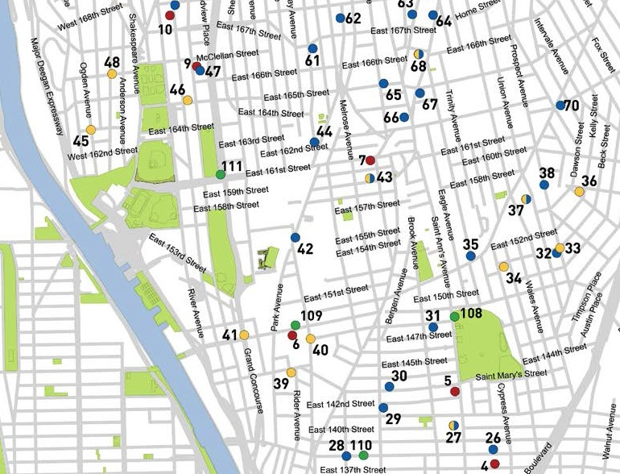
Neighborhood Guide to Food and Assistance - The Bronx edition

Ke Y

SNAP/Food Stamp Office WIC Office
Soup Kitchen Food Pantry
Farmers' Market
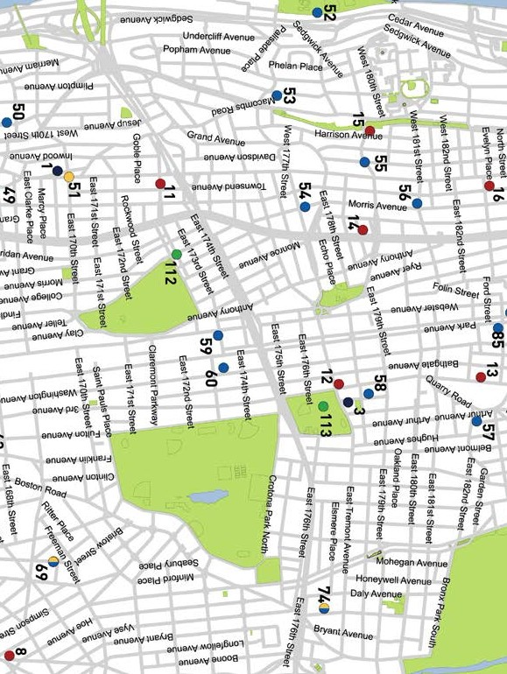
MAP
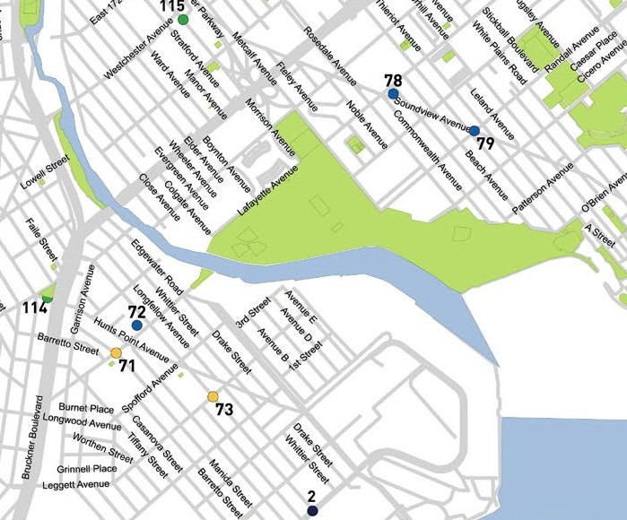
Neighborhood Guide to Food and Assistance - The Bronx edition

Ke Y

SNAP/Food Stamp Office WIC Office
Soup Kitchen Food Pantry
Farmers' Market

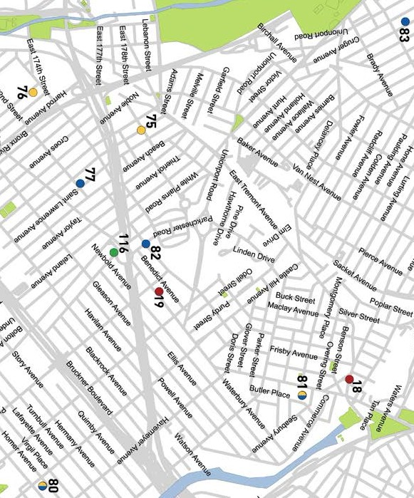
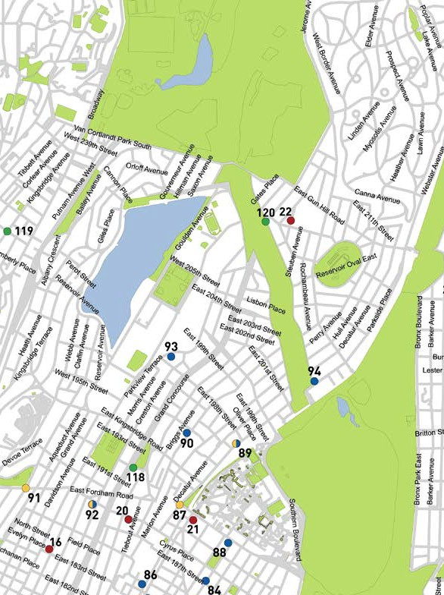
Ke Y

SNAP/Food Stamp Offic

WIC Office

Soup Kitchen Food Pantry
Farmers' Market

Neighborhood Guide to Food and Assistance - The Bronx edition
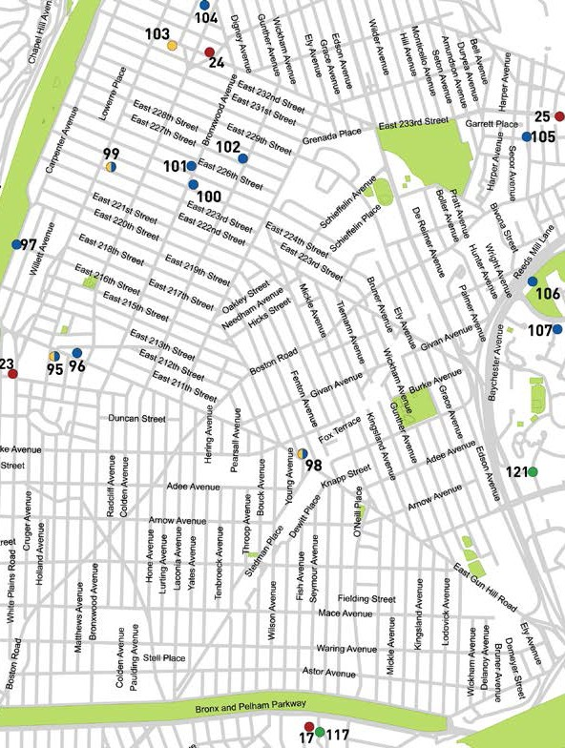
e
OTHER ASSISTANCE
Additional organizations in your neighborhood that can as- sist you with matters other than food support.

MEDICAL CARE

Lincoln Medical & Mental Health Center
234 E. 149 St., 10451
718 579 5000
North Central Bronx Hospital
3424 Kossuth Ave., 10467
718 519 5000
Jacobi Medical Center
1400 Pelham Parkway South, 10461
718 918 5000
Segundo Ruiz Belvis Neighborhood Care Center
545 E. 142 St., 10469
718 918 4000
Morrisania Diagnostic and Treatment Center
1225 Gerard Ave., 10452
718 960 2805
Tremont Health Center
1826 Arthur Ave., 10457
718 918 8750

HEALTH INSURANCE

Affinity Health System
Information regarding health insurance, including enrollment in Medicaid, Medicare and other plans.
General Info 866 694 9809
2831 3 Ave., 10455
301 E. Fordham Rd., 10458
1250 Water Pl. (Metro Center Tower 1, entrance off Marconi St), 10461
38
Neighborhood Guide to Food and Assistance - The Bronx edition

Provides specific and detailed assistance regarding a wide range of legal topics, including agencies that might be able to help you find an attorney to represent you in court.
LEGAL ASSISTANCE
The City Bar Justice Hotline
212 626 7383
Mon–Thu 9am-5pm, Fri 9am-1pm
Free, basic legal advice on a range of civil issues. Will not provide an attorney or assist with in-court representation.
X
MORE HELP
EMERGENCY NUMBERS

National Hunger Hotline 866 3-HUNGRY (866 348 6479)
NYC Hunger Hotline 866 888 8777 Police, Fire or Ambulance: 911 Emergency Shelter: 311
Homeless Hotline: 800 994 6494, 212 533 5151
Immigration Hotline: 212 419 3737, 800 566 7636
Center for Disease Control: 800 232 4636
Poison Control: 800 222 1222
AIDS Hotline: 800 541 AIDS, 800 233 7432 (Spanish)
Alcoholics Anonymous: 212 647 1680
Narcotics Anonymous: 212 929 6262
Gamblers Anonymous Hotline: 855 222 5542
Domestic Violence Hotline: 800 621 4673
Battered Women Hotline: 718 499 2151
Rape & Sexual Assault Hotline: 212 423 2140, 212 227 3000
Child Abuse Hotline: 800 342 3720
Runaway Hotline: 800 786 2929 (800 RUN AWAY)
Crime Victim Hotline: 212 577 7777, 800 689 4357
Suicide Hotline: 800 273 8255
National Crisis Line: 800 999 9999

Credits: Icons adapted from The Noun Project collection. Map data © OpenStreet- Map contributors.
WHAT AM I ELIGIBLE FOR?

Use the chart below to see what for you and your family.

PEOPLE WITH CHILDREN

PEOPLE WITHOUT CHILDREN

SENIOR CITIZENS

HOMELESS INDIVIDUALS

LEGAL IMMIGRANTS

UNDOCUMENTED IMMIGRANTS

SNAP/Food Stamp Benefits
WIC Packages
School Breakfast & Lunch Free Summer Meals
for Children
Meals at Senior Centers Home-delivered Meals


Have any suggestions on guides@hungerfreenyc.or

programs may be available



Groceries at Food Pantries

Meals at Soup Kitchens

how to make this Guide better? Email g.

